Lab Assignment 9 - Other SQL Operations

## Instructions

1. Answer the below question in the boxes.
2. Please submit the assignment through TalentLabs Learning System.

## Open the Movies database

Follow the step illustrated in Chapter 3 to open the Movies database using DB Browser for SQLite. You should see 5 tables in the database.

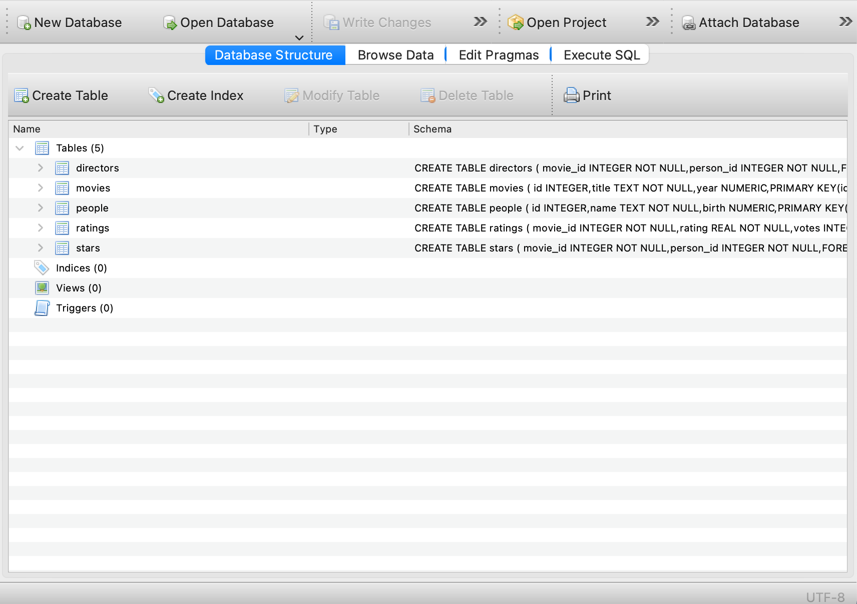

## 

## Query Exercises

1. Write a SQL query to create a table “actors” which has two columns - movie_id, person_id

Expected Output: a new table with two columns - movie_id and person_id

|  |
| --- |
| CREATE TABLE actors (  movie_id INTEGER,  person_id INTEGER  ) |

1. Write a SQL query to insert the movie_id of “Titanic” and person_id of “Leonardo DiCaprio” into the “actors” table, in one row.

Expected Output: A new record in the “actors” table

Hint: You may want to look up the movie_id of “Titanic” and person_id of “Leonardo DiCaprio” first.

|  |
| --- |
| INSERT INTO actors  (movie_id, person_id)  VALUES  (120338, 138) |

1. Write a SQL query to update the record input on exercise 2 into the movie_id of the movie “Celebrity”

Expected Output: The record in the “actors” table being updated to the movie_id of “Celebrity”

Hint: You may want to look up the movie_id of “Celebrity” first

|  |
| --- |
| UPDATE actors  SET movie_id = 120533  WHERE movie_id = 120338 |

1. Write a SQL query to change the table name of “actors” into “movie_actors”

Expected Output: The name of the “actors” table is being to updated to “movie_actors”

|  |
| --- |
| ALTER TABLE actors  RENAME TO movie_actors |

1. Write a SQL query to delete the “actors” table on the movie database. (Be careful not to delete the wrong table, or you will need to download the movie database once again.)

Output: A series of SQL query composed with DROP operation

|  |
| --- |
| DROP TABLE movie_actors |

**- End of Assignment -**